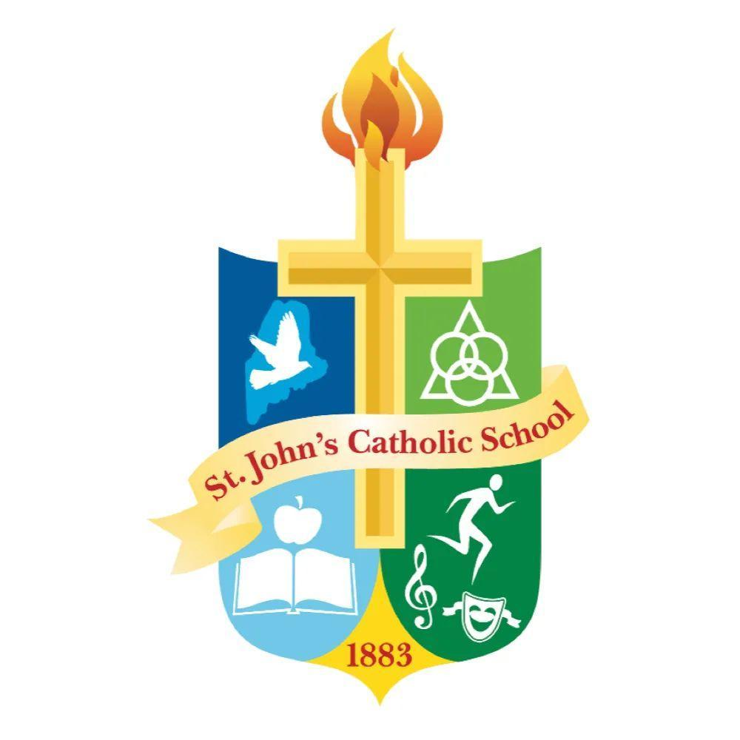
St. John’s Catholic School

PTA Meeting Minutes
October 14, 2026 6:00 PM

- Call to Order 6:02 PM
  - In Attendance: Rebecca Charrier, Laci Weston, Brogan Teel, Kaylee Knudsen, Palmer DePre, Brittany Milligan, Rachel Kelly, Caitlin McCorkle, Danielle May, Chrissy Smith, Amberly Shea, Kathleen Curry, Kellie Teel, Karin Paquin, Louis Sullivan, Amie Marzen, Anastasia LaMarca, Megan Simplicio
- Opening Prayer - Brogan Teel
- Meeting Minutes Review
  - 1M Becca Charrier 2M Kaylee Knudsen
- Treasurer’s Report
  - Checking Account Balance ($239.60)
    - Expenses
      - ($97.20) Moms night out pizza
  - Savings Account Balance $9,158.57
- Bake Sale at Fall Fiesta Craft Fair - Oct 17th
  - At the community center lobby 9-3
  - PTA also offering a raffle of donated crafts from vendors
  - Sign up on link tree for baked good donations – drop off by 9am Saturday to sale table or Friday to community center kitchen
- Book Fair - Oct 18th to 23rd
  - Possible teacher wish lists
  - More opportunities to volunteer available
  - Possible to split timeslots - note when available when signing up
  - Can order online after physical book fair for a period of time and have sales count toward book fair
- Parent Teacher Conference Teacher Meals - Oct 22nd
  - Pats Pizza
  - Will confirm volunteer to pick up teacher lunches for 11
  - Kaylee will follow up on teacher menu
- Dine to Donate pats - Oct 22nd
  - Info on social media
  - The following Dine to Donate will be will be pageant night
- Trunk or Treat - Oct 24th 1-3PM
  - Sign up active for trunks and candy donations
  - Candy donations can be dropped off during car line
- Poinsettia sale
  - Active on link tree
  - Can donate to nursing homes
  - For pick up at family lunch
- Family Lunch - Dec 4th
  - Cate Kerr to chair. Looking for co-chair
  - Pasta Lunch with St. Nick
  - Will have sign up genius for volunteers
  - Possible meatball subs for lunch with leftovers
- St. Nick Shop - Dec 17th
  - Can drop off items to the office
  - Will have a sign up for supplies, volunteers
  - Info on social media
- Other Business
  - Follow up with Mr Sullivan on what teacher needs are
  - Memorial parade for 2027 ideas - Oullettes have float, will check in on status
  - A schedule of catholic schools week a few weeks ahead would be helpful for parents
  - Researching school merch store possibilities- virtual vrs inventory store
  - Discussed fundraising opportunities for businesses in community

Adjourn 7:05 PM 1M Brogan Teel 2M Caitlin McCorkle

Next Meeting Thursday November 12 6:00 PM

